**JENKINS ASSIGNMENT**

1. Create repository in github upload word documents in repository

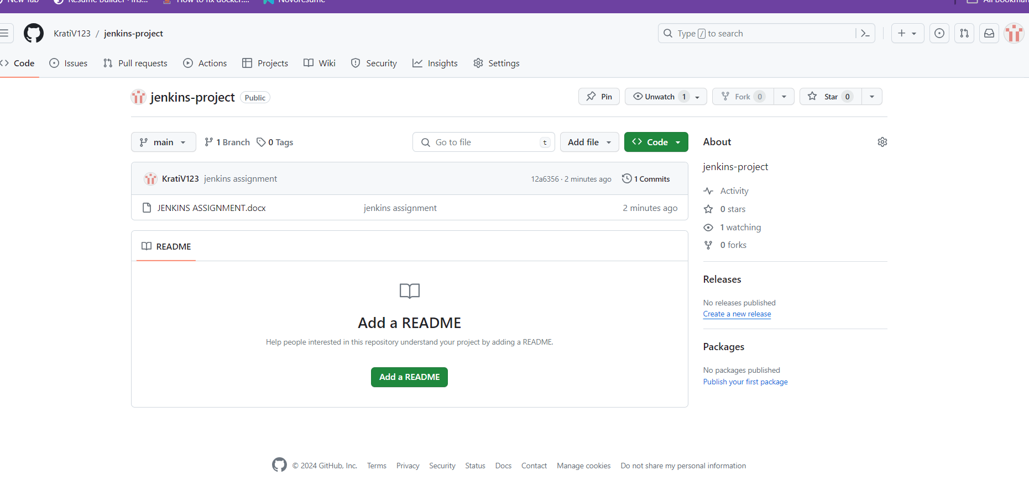

1. Create job in Jenkins create index.html file upload httpd server

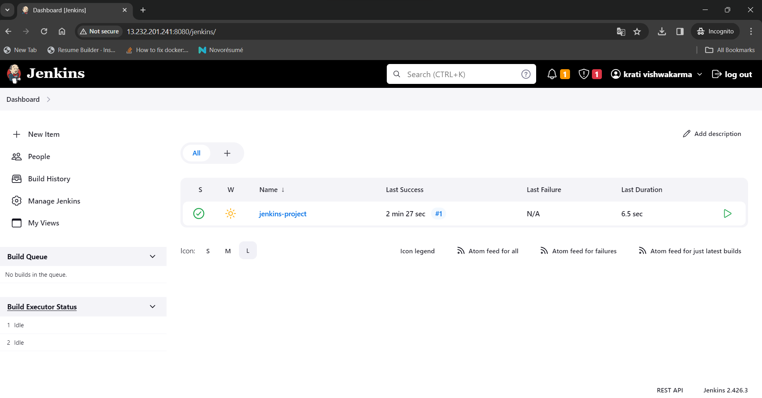

1. Build jobs

